Requirements for BMS software:
Connection screen – connect to BMS over USB Virtual COM port.
If don’t want to connect straight away, offer to load saved configuration, or create new blank config.
User interface must have a left sidebar always present on screen with configuration options relevant to the screen
Main screen: dashboard – views of pack voltage, current, SOC, cell delta, max min and average temperatures, AMS state, precharge state, etc
no config options here
Voltages: Chart of all 140 cells, grouped by segment. (probably bar chart?)
absolute mode and deviation mode. Bar chart should show lines for over voltage and undervoltage thresholds, charge target voltage etc.
sidepanel shows config options for the above.
Thermals: 3D per segment heatmap of all thermistors
Config menu shows overtemp and undertemp settings
Plots: Set up graphs using any variables on either axis
Faults: View present, or historic, faults, with severity shown and freezeframe data of accumulator when fault occurred. Clear faults button
Charging: Menu to start charging, set charge limits etc
General Settings: Other configuration options that can be changed. E.g. cell type, CAN baud rate, etc. Shows current firmware version etc. Option to fetch released firmware versions from github that can then be programmed onto the board. (firmware is different from configs)
Communications: View of the daisy chain interface, identification of segments, etc
Terminal: Text console to send commands manually or view stream of status/debug messages
Design rules:
Colour means state – colour should be used intentionally to convey information about the pack.
Other ui elements are minimal dark mode. Could highlight selected modes in an accent colour also used for logos etc
e.g. vesc tool
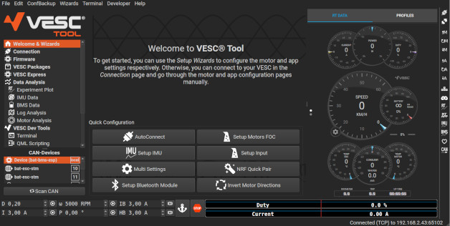
Hovering:
Hovering on any piece of data, shows what cell, thermistor ID, slave board, segment etc that it belongs to.
Clicking on said data adds that channel to the plot window
Stale data: If any data fails to update, e.g. brief loss of usb connection or bms firmware prioritises something else, grey out affected channels and display banner showing stale data message.
Thermal layout comes from a config file mapping each thermistor ID to its XYZ coordinate in the segment

example from claude:
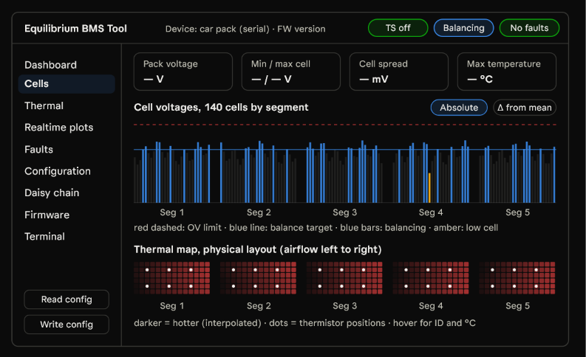
Every connected session must automatically start recording data and logging it.
Firmware updating:
Automatically pull released firmware updates from github.
confirm bms ready to program (TS off, no errors present, etc)
Software reboots the BMS into its bootloader and re-connects over USB
Send firmware
Verify firmware
Offer to re-apply saved config settings

